CIS 284

Week 4 Team Project

Kelcee Chorba  
Christine Jordan

100 points

SCREENSHOTS

Web page 1:

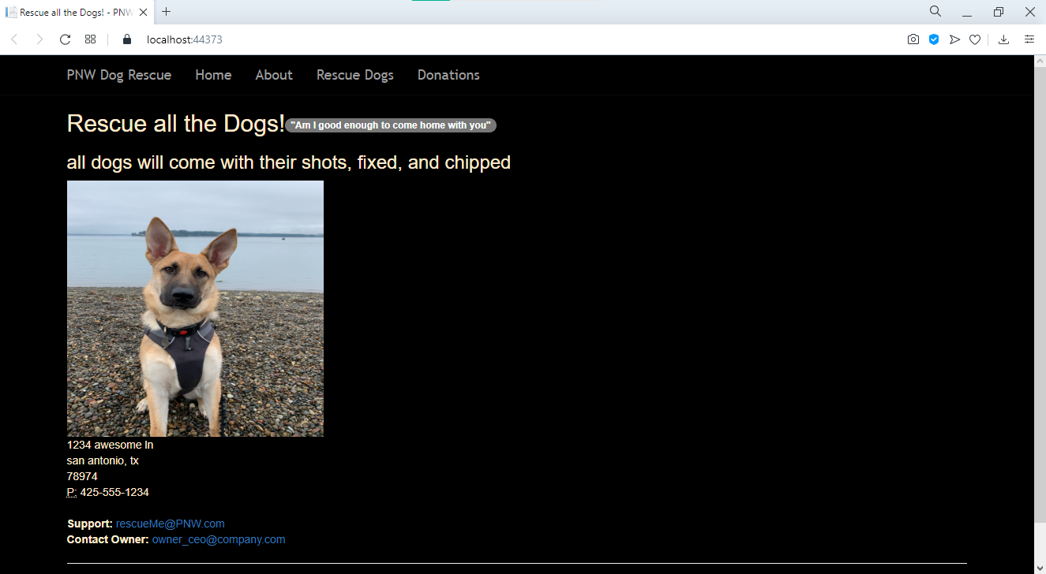

Web page 2:

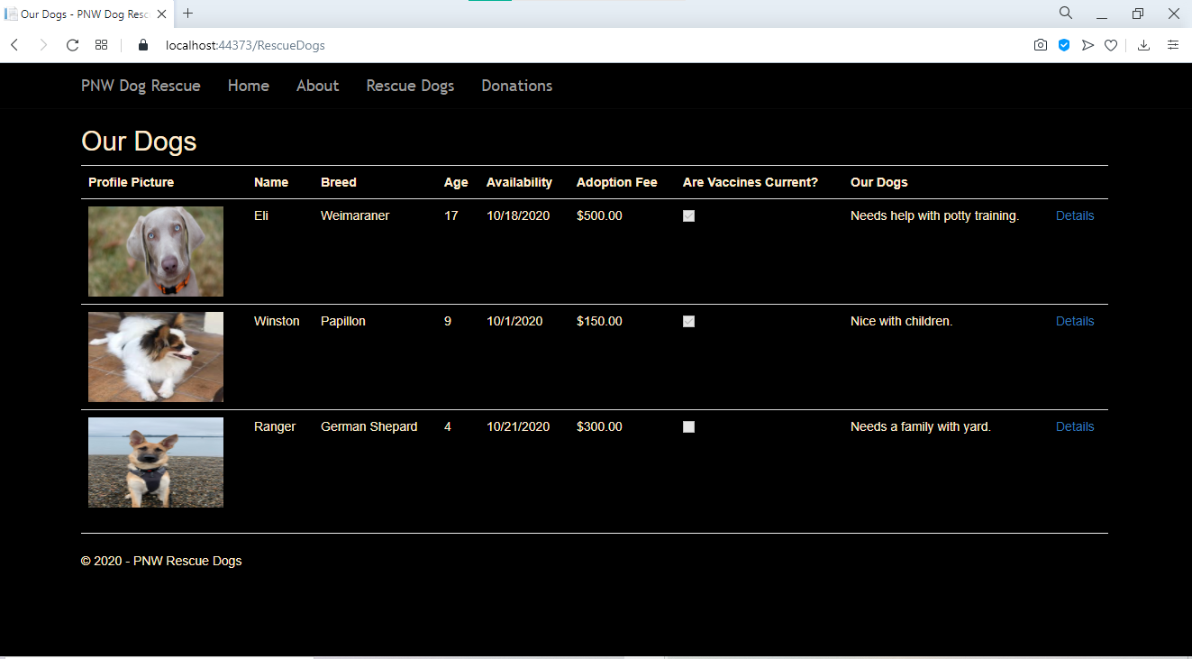

Web page 3:

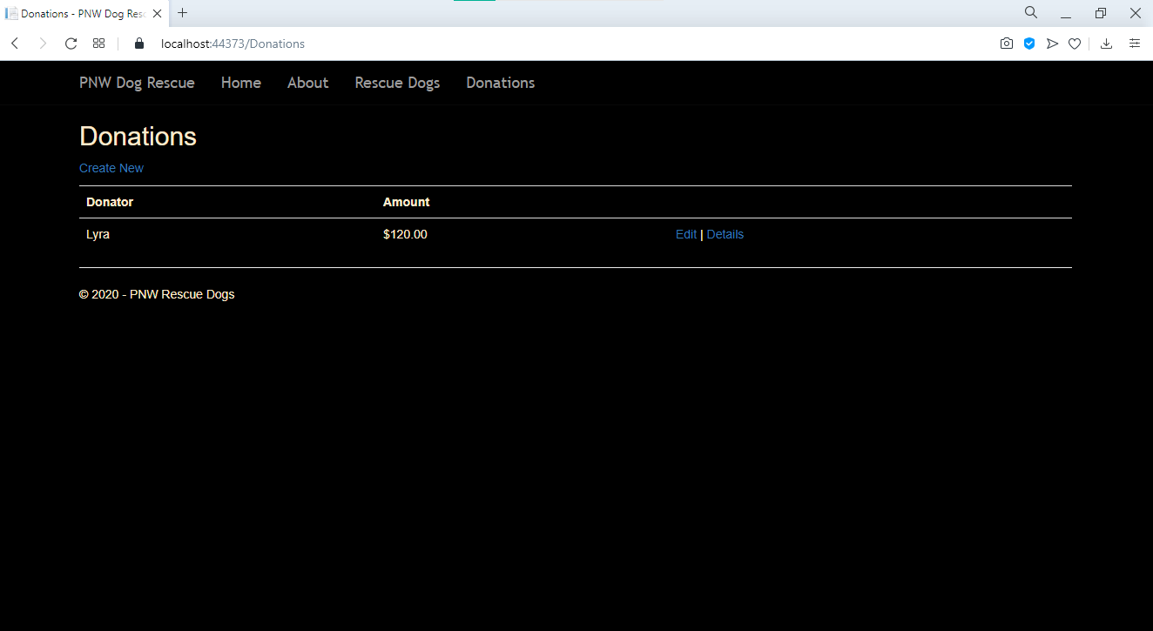

INSTRUCTIONS

This week, you will work in teams of two to create a web site using the skills you’ve learned in class. Your project must meet the following requirements:

1. Each team will create a web site with at least three pages of your own design.  
   It’s okay to use the Microsoft-provided templates for the page header,   
   but the content for each page should be your own.
2. Use the technologies we’ve covered in weeks 1-3, including:
   1. A starter MVC template, either from the lab or included with Visual Studio
   2. Razor syntax
   3. MVC application construction
   4. Some kind of value stored in the model
   5. A view of the model displayed on the web page
3. The work for this project comes in creating content and adapting the textbook structures to the needs of your web site.
   1. Put the names of both team members in comments somewhere in the .cshtml and/or other files in a way that's very easy to locate
   2. Your pages must include images, text, and CSS styling
   3. For this project **only**, plagiarism of content (text/images) is fine so long as the HTML/Razor code is your own. Find pretty/funny pictures on-line and re-use them!
   4. If you find non-trivial pieces of **code** on-line,   
      please do add a comment with the URL where you found the code.
4. Please include a screenshots where indicated above.
5. The project must be complete and submitted by midnight the day before presentations.   
   To submit the project:
   1. Combine all files into a single folder
   2. Add this word document with screenshots
   3. Create a .zip file from that folder
   4. ~~Test the .zip file on a different classroom computer to be sure your site works when moved to a new location.~~
   5. Turn in the zip file to the professor on-line.
6. Your team will show off your web sites in front of the class, explaining the topic of your project and stepping through common actions. You need not demonstrate everything on your web site during your presentation. If presenting web sites on the instructor computer proves problematic, you’ll show the screenshots submitted in the Word document.

CHECKLIST FOR SUBMISSION

* Use all required technologies
* Team member names in source code comments, somewhere very easy to find
* This word document with screen shots included in .zip file
* A test confirms the web sites can be viewed correctly from the .zip file your team submits
* Submission is in by midnight before the presentation

RUBRIC

Page design: 30 points total, 10 points each

Required technologies: 30 points total, 10 points each

* model for some kind of data – variables and/or database
* controller
* view

Screenshots and Word document included in submission: 10 points

Front-of-class presentation: 20 points

Creativity and extra effort: 10 points

SAMPLE C# FILE COMMENT

/* Developed by Faith Robinson and Jack Patel */

SAMPLE HTML FILE COMMENT

<!—Developed by Faith Robinson and Jack Patel -->

HOW TO APPROACH THIS PROJECT

You have four, one-hour class sessions to complete this project! You will put together something rough and improve it as time goes on.

Day 1: Team up, form initial plan

* Form your team
* Choose from the instructor-provided list of projects
* Sketch out the big picture of what pages are required, and how the labor can be split up
* Begin to develop your individual pieces

Day 1-3: Create web pages, including controls and .cshtml

* You will need to create text and download images for use on your web site
* *For this project only*, plagiarism of content is encouraged.   
  Find useful pictures on-line and copy them if they are useful.

Day 4: Integrate your pages and submit the combined files to your professor

* Load your web site on a completely different computer to be sure it works from the .zip file

Day 5: Show off!

* The file must be submitted by midnight the morning of the presentations.  
  Files submitted after this time *will not be accepted for presentation*.
* The instructor will unzip your .zip files on the instructor workstation. You will run your site through visual studio to demonstrate operation and information exchange. Feel free to pre-load sample data to make the presentation smoother.
  + If presentation deployment becomes a problem, we will use the screenshots and the Word document you submitted to run presentations.
* Take a few minutes to tell the class:
  + Who is on your team
  + Which project your team chose
  + Demonstrate the basic operation of the web pages
  + Point out one neat things you've done with the code
* Plan to talk to the class for about five minutes. It may be easier to present if the whole team comes up, but it is acceptable appoint a spokesperson for your team.